How to Become a Visionary Inspiring Purposeful Leader

THE StageSHIFT V-I-P SYNERGIST LEADERSHIP
PROGRAM FOR SENIOR EXECUTIVES

Be bold. Be brave. Be more.
WELCOME!
StageSHIFT is a coaching and consulting company. We design and run Leadership Programs for Senior Executives.
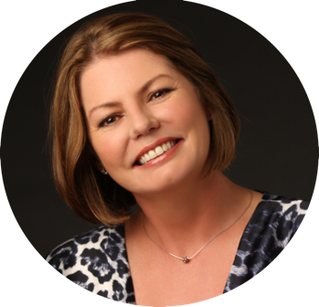
We specialise in Advanced Vertical Leadership Development so Executives quickly develop the mature Synergist Mindset and Transforming Worldview of a Visionary Inspiring Purposeful Leader of their business ecosystem.
We’re known for quickly enabling Senior Executives to develop this urgently needed level of leadership capacity in 1-2 years instead of the usual 5-6 if the right blend of active ingredients are present – most often they’re not.
VIP Leaders can lead business renewal and industry transformation with ease and confidence while creating more sustainable, healthy, and equitable outcomes in our increasingly D-VUCA-BANI world for all involved.
We offer: Dr Antoinette Braks
Founder of StageSHIFT
 | SWIFT VERTICAL DEVELOPMENT | It was commonly thought to take 5-6 years to master the upgrade to an open Synergist Mindset and Transforming Worldview needed to transcend VUCA. StageSHIFT delivers this advanced leadership capacity in just 1-2 years.
 | POWERFUL BUSINESS OUTCOMES | Client organizations have doubled the Leadership Effectiveness of their top 75 senior leaders in 2-years, doubled the Engagement of 1,000 people in just 6-months, and a 50-p trading company doubled its business revenues in 3-months!
 | DEEP LEADERSHIP EXPERTISE | Dr Antoinette Braks, Founder of StageSHIFT, is a global thought leader, author, speaker, and Award-winning Master Coach in Vertical Holistic Leadership and Systemic Org. Development for Senior Executives to develop a Synergist Mindset.
 | BROAD GLOBAL COMMUNITY | Our growing community of Certified Master and Professional StageSHIFT Coaches have led outstanding international careers and gained extensive coaching experience with Senior Executives in divisional, regional, and global roles.

THE PROBLEMS WE SOLVE
It’s impossible to be effective in a Senior Executive role using the type of driving leadership style of a business unit leader or team captain that would’ve worked well in the past. You’re now in the role of the conductor of an orchestra!
All you have is the musical score to create alignment, your baton to keep time, and your presence to set the tone. You need everyone on the same song sheet, playing their role to the same beat. It’s your job to generate the opportunity for a powerful, magical performance seemingly without saying a word, playing a note, or taking a pause.
Here are three common challenges that may strike a chord with you!
Stuck in the weeds of operations!
You want to do strategic work, but you’re stuck in day-to-day operations as teams are not taking enough accountability and you’re not sure they’ll get it right. You’re working long days and just don’t have enough time in the day to cover everything. In a recent PwC Report, half of all CEOs admitted to being mired in operating issues even though they believe their company will not be viable in 10 years’ if it stays on its current path.
I’m working big 12-hour days, to 8.30pm; it’s affecting my home life.

I think I’m in trouble!
Performance anxiety and political rivalry gets more intense at senior levels. Market exposure increases, career risk magnifies, and you’re in a bigger spotlight. The additional stress incites people to demand more of others and undermine them too. You may feel threatened and find it all quite upsetting! The irony is that these same colleagues are now responsible for role modelling the desired values-based culture.
My position is under threat. There’s been a litany of allegations.

Have I really got what it takes?
Life just got a whole lot more complex. The upward trajectory of your career felt great but now every day leaves you feeling exhausted. You wonder if the extra responsibility is worth it! In fact, you’re not really sure you’ve got what it takes. You’re starting to feel awkward, and don’t really know what to do differently. Chances are you could make a mess of it and even get fired before you get it together. What will you do about it?
I’m terrified about the day and my ability to work as an executive; it’s so messy.

If you’re nodding your head, you’re in good company. Around 60% of new executives fail in the first 18-months. 76% say that formal development processes were inadequate and 55% that coaching services were subpar (US Corporate Executive Board).
THE REWARDS YOU GAIN
The 8-Step StageSHIFT VIP Synergist Leadership Program enables you to become a Visionary Inspiring Purposeful Leader of your business ecosystem, like the conductor of an orchestra, in just 1-2 years instead of what is commonly thought to take 5-6 years provided of course you have the right blend of active ingredients.
We’ve discovered that the fastest way to create a breakthrough is to prioritise uplifting the systemic organizational context with what we call Systemic Strategic ScaffoldingTM. By changing up the playing field and the rules of the game, everyone on and off the field naturally adjusts their perception and approach. This ignites development across the board lifting accountability and agility at each level of the organization.
Here are three strategies you can implement to totally transform your situation.

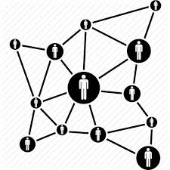
Change up the playing field
By transforming the playing field, you’re upgrading the systemic context. By building on what there is already, you’re in the orange light zone where you don’t need permission. Most command/control organizations inhibit leaders stepping up. But once you reset strategic direction and put the systemic scaffolding in place, your people will take accountability for operations, and you’ll step up into strategic work as if by magic!
I tore down the transactional framework. It’s unheard of to hit deadlines like this as consistently as this. Met every single deliverable on time every time. Amazing!

Resolve your human shadow
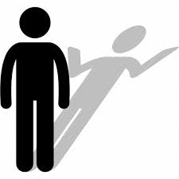
Few leadership programs go deep enough into emotional dissonance to eliminate triggers and reactive patterns. They focus on regulating your responses rather than healing the source of patterns that were set up in childhood to keep you safe. When young, we don’t have the cognitive or conscious capacity to work through the issues. A deep dive into shadow resolution leaves you with a calm and clear, discerning mind.
I was always intolerant of fools and cranky idiotic people behaving badly ... Realising they are doing the best they can was a huge shift ... Biggest shift of all!

Find your aspirational why
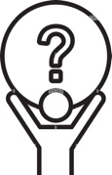
One of the keys to extraordinarily effective VIP Synergist leadership is speaking out with an aspirational Visionary Purpose that is widely and enthusiastically shared. This creates intrinsic strategic alignment in sync with the quantum field of evolution. Intuitive insight expands, and you’ll delight in the challenges, resources, opportunities, and people that arrive custom-designed for your growth and success.
Less pushing, more patience; less striving, more appreciation; less holding onto things, more letting go to trust in others. My mind has quietened.
.
THE VERTICAL JOURNEY
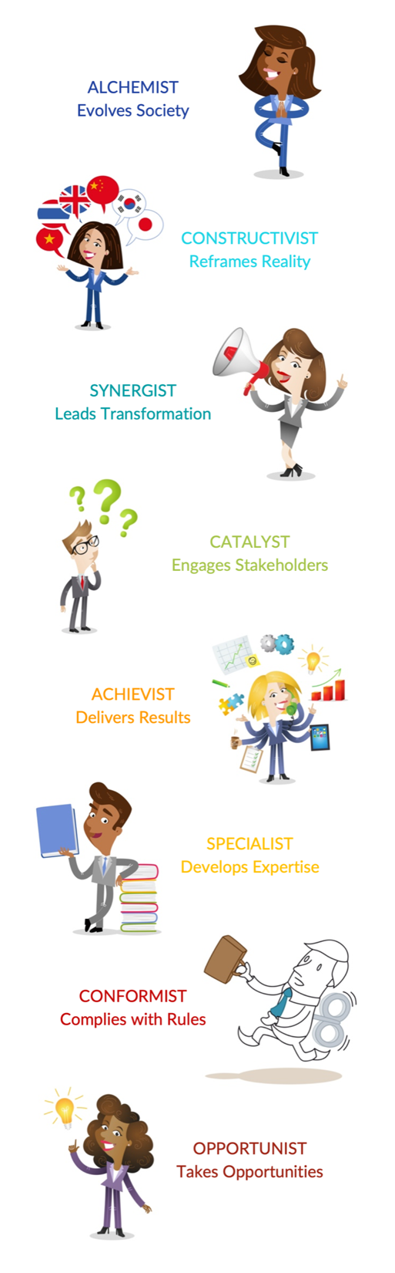
While the evolutionary journey is unique for every individual, it is also universal. Constructive developmental psychology sets out a series of Stages through which we can evolve and mature as adults.
3rd
4th
5th
2nd
1st

THE ACHIEVIST
The primary Stage of the majority of business leaders is Achievist, the high performing leader who can be counted on to make customers happy and achieve consistent results. The preceding Stage of Specialist reflects a leader who refines and leverages their expertise. They are still task-facing rather than market-facing. The Specialist and Achievist form the two Stages of Awareness and Integration in what is called the 3rd Perspective.

THE CATALYST
There is a growing percentage of leaders with their primary Stage at Catalyst, the initial Stage of Awareness in the 4th Perspective. Catalysts are change leaders who navigate effectively across boundaries to engage stakeholders. They bring the art of inquiry and authentic collaboration to realize more sustainable longer-term outcomes. Executives with their primary Stage at Catalyst are growing at the rate of approximately 11% per decade.

THE SYNERGIST
The second mature Stage of Integration in the 4th Perspective is the Synergist. They have the expanded consciousness to transcend the VUCA systemic context and hold the inner integrity to lead the evolutionary transformation of the business ecosystem. Only leaders with a Synergist mindset, or those partnering with trusted Synergist or Alchemist advisers, have successfully led industry renewal. Currently less than 10% of Executives have a primary Synergist mindset and the rate of growth is a mere 1% per decade.

SYSTEMIC HOLISTIC LEADERSHIP DEVELOPMENT
Our deep expertise in Vertical Holistic Leadership and Systemic Organizational Development combined with decades of experience leading systemic transformation, provides us with profound insights and breakthrough frameworks to guide the transformative journey of Senior Executives to the relatively rare yet urgently needed level of Synergist. Our proven accelerated pathway guarantees success.
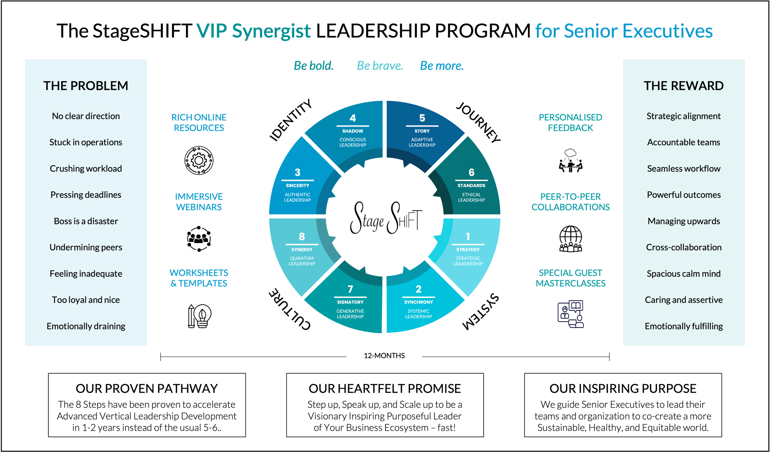
When you are inspired by some great purpose, some extraordinary project, all your thoughts break their bonds; your mind transcends limitations; your consciousness expands in every direction; and you find yourself in a great new and wonderful world. Dormant forces, faculties and talents become alive, and you discover yourself to be a greater person by far than you ever dreamed yourself to be. Patanjali, Hindu Yogi Mystic

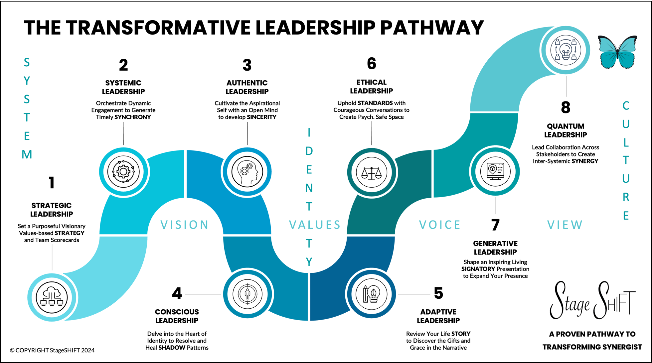
THE 8 STEPS TO VIP SYNERGIST LEADERSHIP
The 8 Steps form a transformative pathway analogous to the metamorphosis from caterpillar to butterfly. First, we lift the playing field with Strategic Systemic Leadership. Then we dive deep into Authentic Conscious Leadership to lift our self-expression and resolve shadow. We rise again with Adaptive Ethical Leadership reinventing our identity in the process. By reframing our history, we chart a new destiny. We re-emerge an octave higher at mature Synergist free to demonstrate Generative Quantum Leadership across the business ecosystem.
OUR DEVELOPMENT STRATEGY
We work with our clients: senior executives, executive teams, divisions, regions, and organizations, to generate a StageSHIFT for each level of leadership and the corporate culture as a whole, simultaneously: self, other, system, and culture. Our Systemic Strategic ScaffoldingTM adds upper playing fields at 4th Perspective so that Senior Leaders and Senior Executives can expand their leadership capacity in more exhilarating and transformative ways. We engineer empowered matrices, agile networks, and interconnected alliances.

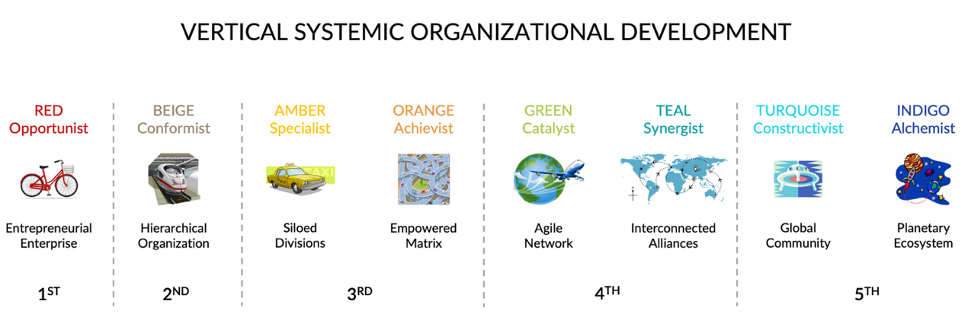

By integrating self and system, journey, and culture, StageSHIFT generates accelerated and, even more importantly, sustainable outcomes that lead to realizing your highest aspirations in service of others and all life on our planet. The traction of simultaneous vertical leadership and organizational development organically provides the type of heat experiences that invite senior executives to step up, dive deep, and speak out.
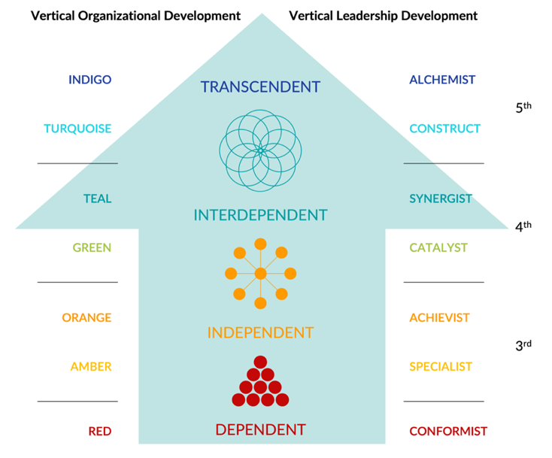
We guide and support you with our proven toolkit and immersive Discovery Dialogues so you can tap into your vast latent potential, leverage every opportunity, and master every challenge.
The beliefs that underlie our holistic techniques and templates derive from a mature 4th Perspective. They are quite different from common standard 3rd Perspective approaches to mindful and emotional intelligence. We inquire with you into the source of your intrinsic understanding of your self-identity, to enable you to shape your life experience and career success more consciously and intentionally.

The higher our self-expression and the deeper our self-awareness, The richer our life experience, and the greater our soul evolution. Antoinette J Braks
OUR LEARNING ARCHITECTURE
We offer our proven RADAR Learning Architecture to accelerate your development and effectiveness.
Our rich online resources give you a command of each subject in REVIEW & REFLECTION. The worksheets and templates found under AWARENESS & ATTENTION shortcut your learning curve. Bu customising them to your situation, you can experiment with implementation risk-free by following our guidance on the process.
We hold 40+ live online immersive webinars each year – DISCOVERY DIALOGUES. You ask questions, share interpersonal challenges to receive coaching, and show us your masterpieces-in-progress to get immediate personalised feedback on your ASSIGNMENTS & APPLICATION. You’re also invited to collaborate with peers to refine and rehearse your work and share your RESULTS & REVELATIONS online. We’ve got you!

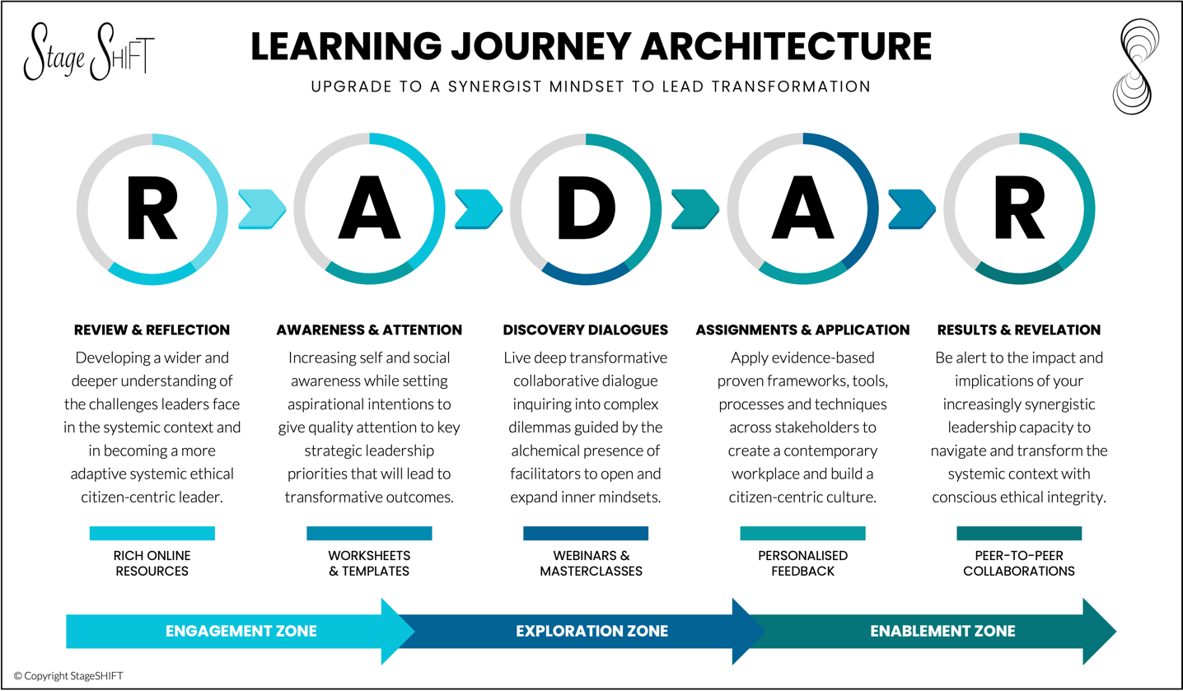

Your choices are trial and error, quick fixes, executive coaching, leadership programs renown for being inadequate, or a holistic systemic 8-step solution that’s been proven to work quickly and universally for intelligent, formerly highly successful Executives who need the level of consciousness and knowhow to step up confidently to the next level! You avoid the pitfalls of experimenting with new approaches yourself and get the support you need to win the trust and confidence of others to succeed. We guide your hero’s journey.
Our StageSHIFT VIP Synergist Leadership Program is a “Done With You” type of Program. We partner with you to ensure you embed and embody a Synergist mindset, become a truly Visionary, Inspiring and Purposeful Leader, and achieve aspirational business outcomes you set with your team, division, organization, and stakeholders in your business ecosystem. We travel with you along the way to ensure your success. We also offer supplementary services such as Vertical Systemic and Strategic Team Dynamics Workshops.
OUR VERTICAL ASSESSMENTS
To track your increasing effectiveness as a leader we invite you to undertake three Vertical Assessments: the StageSHIFT VIP Synergist Scorecard, the Global Worldview, and the Vertical Holistic Leadership Profile.

THE StageSHIFT VIP SYNERGIST SCORECARD
This is available for you to do now. It’s complimentary. Benchmark your capacity to excel in the complex adaptive systemic context of a Senior Executive’s role. It’ll take 5-10-minutes to answer Yes or No to 50 questions and offer your thoughts on 3 open questions. You’ll then receive an online report and pdf with your score on each of the 8 Leadership Dimensions of the StageSHIFT VIP Synergist Program, along with a set of actions you can take to improve your score.
Click Here to Take the Scorecard

MY WORLD VIEW (MWV)
This is part of the StageSHIFT VIP Program. You complete a series of 30 sentence prompts, and a day later you’ll receive an online report and video to take you through it. The report provides you with an accurate objective assessment of your current primary mindset e.g., Specialist, Achievist, Catalyst, or Synergist.

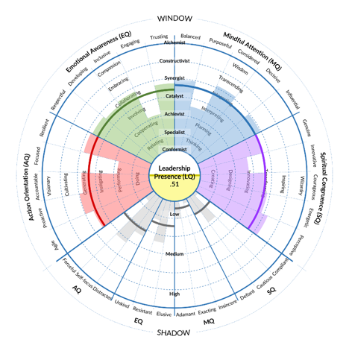
THE VERTICAL HOLISTIC LEADERSHIP PROFILE (VHLP)
This is also part of the Program. It’s a capability-based assessment across 6 levels of Leadership from Specialist to Alchemist. It takes 50-60 minutes to assess yourself on 156 capabilities and shadow elements. Once submitted, you’ll immediately receive an online report, and a pdf will be emailed to you. The 40-page Report takes you through Vertical Holistic Leadership Development, and identifies your Top 7 Strengths, Blind Spots, Stressors, and Stretches. Online videos and templates guide you to create a 12-month Development Map for your uniquely personal journey in the year ahead and we offer you a one-to-one 90-min Discovery Debrief to deepen your understanding.

THE LEADERSHIP CIRCLE INDIVIDUAL 360 (TLC)
This is an optional extra if you are interested in your team, division, region, or organization undertaking a vertical-based 360 Assessment. We recommend The Leadership Circle for senior leaders. It is also a capability-based assessment instrument that documents the pathway from Reactive to Creative Leadership and offers valuable aggregate scores for Reactive/Creative, Task/Relationship balance, and Effectiveness.
There is also a more generic Leadership Circle Culture Profile if you want to take the pulse of the culture.

You’ll receive links by email to undertake the Vertical Assessments within 24 hours of registering for the Program. We’d like you to complete these as soon as it’s convenient during the first week or two. You can get started with the online Program by finding out more about the Psychology, Structure, and Nature of Vertical Leadership Development, and then book your individual Discovery Debrief with your StageSHIFT Coach.
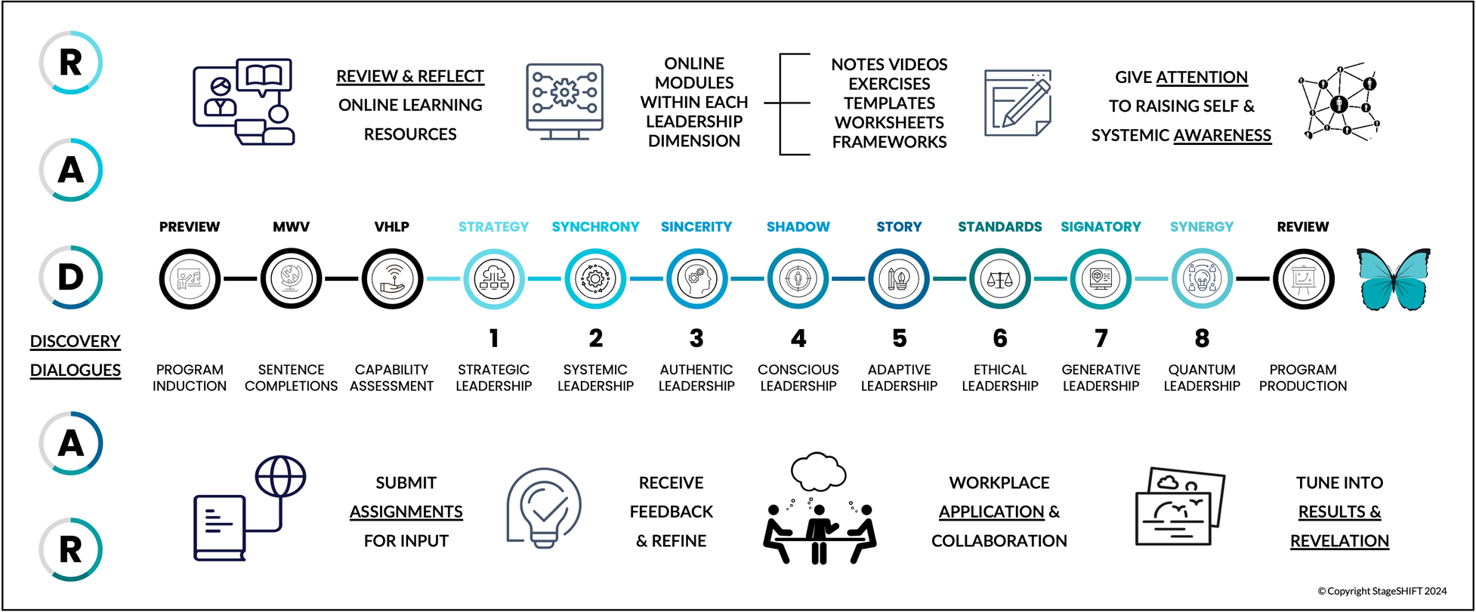
PROGRAM OVERVIEW
The StageSHIFT VIP Synergist Leadership Program begins with two Vertical Assessments including a 90-minute individual Discovery Debrief with your StageSHIFT Coach. As soon as you register, you get access to the online resources on Vertical Holistic Leadership Development, as well as STRATEGY and SYNCHRONY so you can begin to customise the frameworks and exercise stronger Strategic and Systemic Leadership to uplift your part of the organization. This will give you lots and lots to get on with.
The rich online resources including worksheets and templates, integrate with the 40+ 90-minute live online group Discovery Dialogues so you can get quick feedback and make rapid progress. People tell us that the depth of insightful conversation we enjoy during these group masterclasses is not something they experience elsewhere. We are graciously direct, and we go deep fast. Through the Peer Collaborations you will enjoy the company and camaraderie of fellow travellers along the way.
The RADAR Learning Architecture creates an accelerated learning environment. With your commitment and initiative, backed by our knowhow and guidance, your active participation in the StageSHIFT Program will lead to outstanding Results and illuminating Revelations. Life will be forever changed as you step up, speak up, and scale up!
TRANSFORMATIVE COACHING
StageSHIFT Coaching is in a different league from most Executive Coaching as we practice Transformative Coaching, a level beyond Developmental Coaching. This has a significant impact on reachable outcomes.

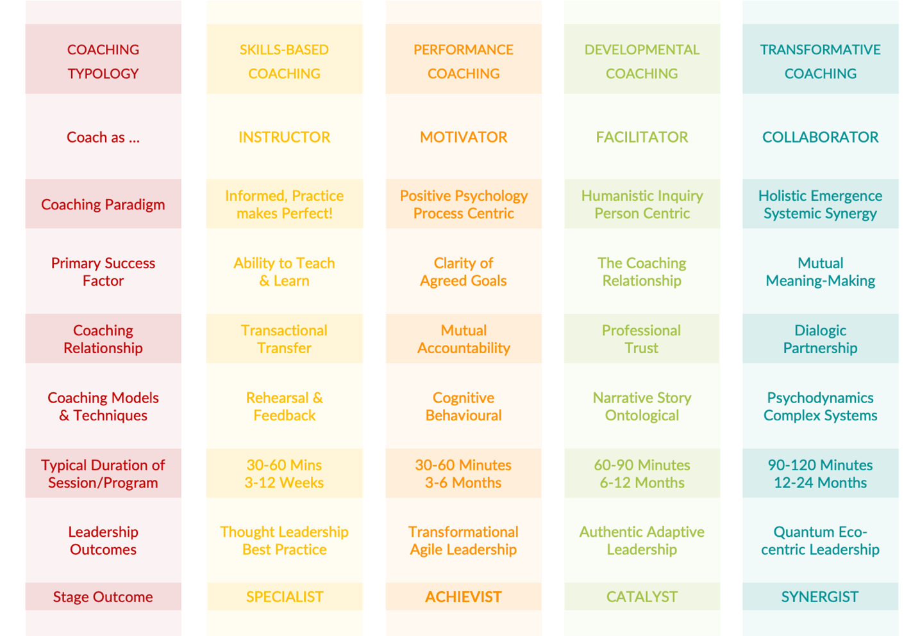

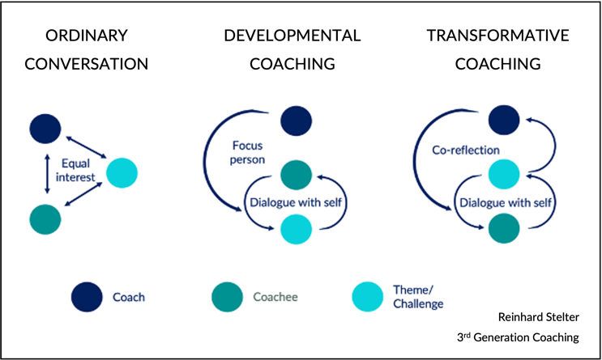
As Transformative Coaches, we practice 3rd Generation Coaching. Beyond supporting your dialogue with yourself, we hold a more expansive space between us, for us both to access and share insights that emerge from deeper layers of our merged consciousness.
The degree of success of a coaching intervention depends on the interior condition, the consciousness, of the coach. As StageSHIFT Coaches are at mature Synergist and beyond to mature Alchemist, you will be beautifully supported to explore and resolve dilemmas that are just beyond your grasp.
WHAT PEOPLE SAY
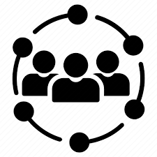
New focus on higher strategic issues
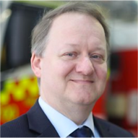
When I first met Antoinette, I was fatigued, stressed at work, and not enjoying life. In the very first meeting, the underlying issues were exposed. She shed light on my life and revealed things that I simply had not seen nor understood. Her positive, forward-looking approach made me feel optimistic. Antoinette helped me work through changes in my org. structure to enable me to focus on the higher strategic issues I enjoy. And most importantly, she addressed my whole-of-life progression, not just my work-life. CIO

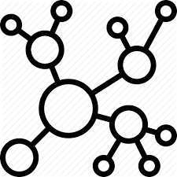
I can now hold my own as a Senior Executive
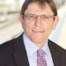
I took up coaching with Antoinette to become more strategic and confident. Her fast-paced approach mixing theory and practical advice was extremely helpful. I always looked forward to our meetings because I knew that I would learn something new and useful. I now have a framework to approach strategic issues and many tools and techniques to draw on so I can hold my own in a senior executive environment. I would not have thought this possible a few years ago. Group Executive Director HSE

Overcame almost insurmountable challenges
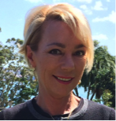
I was dealing with a very complex personal and commercial situation which Antoinette was very quick in understanding the holistic picture. Her commercial experience together with insight into situational dynamics and personality patterns greatly assisted me in breaking the complexity down into manageable pieces to find positive forward moving paths. Importantly, she gave me the confidence and courage to implement what I had considered an almost insurmountable challenge. CEO Manufacturing Sector

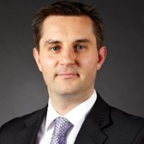
Realized my career aspirations
Antoinette supported me to advance my career and I was extremely impressed. Her ability to provide constructive feedback was invaluable and insightful. Our interactions allowed me to reflect on my purpose and consider a more holistic appreciation of the impact of my body and verbal language in the C-suite environment. She really invested in my success, and I recommend her to others focused on extending themselves to realize their career aspirations at CXO level. GM Strategy & Innovation Energy Sector

Helped me to find my “Voice”
Antoinette impressed as an expert in leadership and the development of personal power. Her style is thought provoking and challenging, yet informal, adaptable, encouraging and fun! Whilst I thought some of her ideas were outside the box, Antoinette's guiding questions and insights helped me to find my "Voice". The fluidity of our conversations sparked off many new ideas and paths to follow. It was a truly fulfilling experience and the outcomes were fantastic! Executive Director, Global Investment Bank
THREE CASE STUDIES
CEOs come to us when they want to uplift their leadership, people, culture, and business performance.
Our first ever client was the CEO of a commodity trading company that had grown to 50-people. They were struggling with team dynamics, a few underperformers and negative people, and their business growth had stalled. This was impacting their culture. People were not as enthusiastic as they once were.
We began with the StageSHIFT Systemic Strategic ScaffoldingTM followed by Holistic Leadership Development. As we re-aligned teams, we let a few people go. Just three months later, the CEO showed us a financial report. Revenues had actually doubled in those three months! And business had become fun again!
FROM GOOD TO GREAT!
The CEO of a business services company formed by amalgamating 1,000 people from various IT, HR, Property and Project Divisions was concerned by the low morale. People felt abandoned and lost. Most didn’t know each other and yet had to find a way to work together to streamline diverse processes and align cultural norms. It was not surprising that People Engagement was down at the 30th percentile and customers were unhappy.
The StageSHIFT systemic approach was perfect to create strategic alignment and team cohesion around the central theme: From Good to Great! Many OD strategies based on the new I-CARE Values and Link-In identity revived a sense of community. Liberating Meetings and Leadership Development for Senior Leaders became embedded. While challenges arose with the Board and Union, we sustained our efforts and the new culture prevailed. People Engagement doubled within 6-months to the 60th percentile, and the business flourished!
The StageSHIFT Program is unique in that it takes a holistic approach to galvanizing transformation. Antoinette has clear insight into how to make momentous changes in perspective. Her strong strategic focus and gracious understanding of people mean you will gain far more than you may expect. Did I say there was a whiff of culture change in the air? Well, I mean there is a gale force wind blowing and the organization and its people are the ultimate winners. ~ Anne Cosgrove Executive Director People & Culture

C-O-N-F-I-D-E-N-T LEADERS PROGRAM
The CEO led a public sector organization made up of 1,000 people focused on Agriculture going through a restructure. Things were tough out there for farmers due to several severe droughts. Country towns were depressed, and prices weren’t high enough to create profitable returns for many. Farming was under threat.
StageSHIFT worked with the new Senior Executive Team to set and cascade strategic direction. This immediately rallied the troops. Based on our 8-Step process, we ran quarterly 2-3-day leadership workshops for the top 75 leaders at different locations as people were widely spread across the region. Over a period of 2-years, their Leadership Effectiveness doubled from the 60th to the 80th percentile, and farming revived.
Antoinette instigated a terrific collaboration with us by leading a Strategic Off-Site for our new Executive Team. She then ran a StageSHIFT Leadership Program around our CONFIDENT Values to uplift our performance. Her broad strategic perspective and deep insights into mindfulness, emotions, courageous authenticity, and team accountability stimulated a significant shift in our ability to collaborate with business partners to build a thriving sustainable agricultural sector in NSW. ~ Michael Bullen DDG
THE PROGRAM ELEMENTS
We’ve told you about the evidence-based 8-Steps that will accelerate your development as a VIP Synergist Leader to 1-2 years instead of 5-6. You’ll simultaneously evolve your part of the organization and business ecosystem leading to significant increases in collective leadership effectiveness, people engagement, and business performance. But that’s not all. Your personal wellbeing will rise, and work will be exciting again!
We implement our RADAR Learning Architecture so you access the materials online, apply our proven method, and have the support, guidance, and encouragement of StageSHIFT Coaches running live online group webinars. We’ll offer you expert personalised feedback to close the gap between customisation and implementation. You can also talk through ideas with peers, rehearse scripts, and have fun helping each other!
Our clients have won Career, Speaker, and Industry Awards, Public Service Medals, realized unprecedented business success on massive critical projects, and received rapid multiple promotions to larger roles. With StageSHIFT, you can quickly move from feeling out of your depth, to turbo-charging your career and enjoying the many benefits of success, happiness, and making a transformative difference in your niche in the world.
Here’s a summary of the value of each component of the StageSHIFT VIP Synergist Leadership Program.
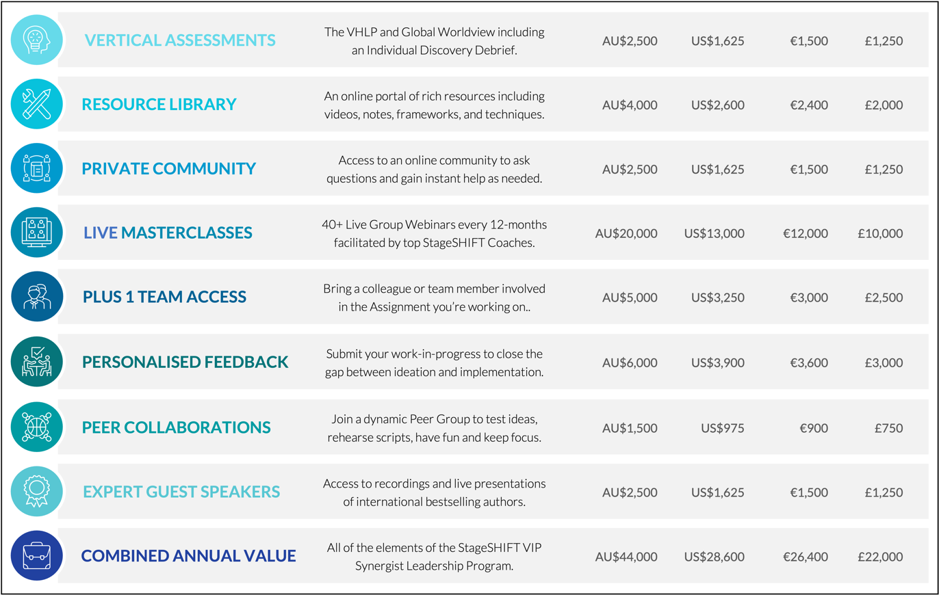

In summary, we offer a proven 1-2-year fast track to step up to Senior Executive VIP Leadership. We invite you to invest just half of the above listed value, estimated to be less than 10% of your current income which, due to your success, will inevitably and exponentially increase with more rapid promotions in the ensuing period.
We offer a range of monthly payment plans to suit.
Set up a meeting with Dr Antoinette Braks or your StageSHIFT coach to find out more.
NEXT STEPS
Discover Your Score on the StageSHIFT VIP Synergist Leadership Scorecard
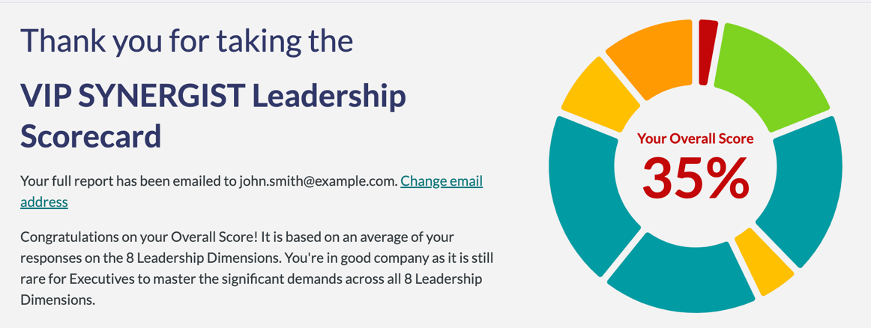
Click Here to Take the Leadership Scorecard

https://stageshift.scoreapp.com

Register for our Free Introductory Program to gain a fuller understanding of Vertical Development.
Click Here to Register for our Free Program

https://www.stageshift.coach/

Set up a Discovery Call with Dr Antoinette Braks to find out more and see if it’s a fit for you.
Click Here to Set Up a Discovery Call

https://calendly.com/antoinettebraks

Accelerate your career! We look forward to enabling your success!
Be bold. Be brave. Be more.

