Corinna Kingston

Ireland & UK ; Language English
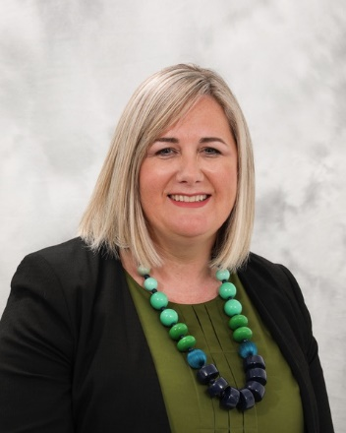

Corinna’s professional experience spans over twenty years in corporate working across the business from operations to directorship level in several European locations. Corinna has amassed a wealth of expertise in international business and experience developing and growing cross-cultural teams. Corinna has always been a big believer that people are any companies’ greatest asset and is an advocate of drawing out the best in individuals and teams through developing their strengths. After becoming disillusioned by corporate landscape, Corinna decided to follow her passion of supporting the growth of businesses, communities and our planet in more sustainable ways which is how she came to vertical leadership development.

As a fully accredited EMCC Senior Practitioner Executive Coach and licensed GLP (Global Leadership profile) debriefer, Corinna follows a holistic approach, working with the whole person encouraging them to show up as their most authentic selves whilst co-creating a compelling future. Corinna is compassionate yet honest and direct in her approach. Corinna’s deep listening skills and her ability to work intuitively with her clients fosters trust and empowers clients to evolve into greater versions of themselves and be more impactful in their organisation.

www.corinnakingston.ie
https://www.linkedin.com/in/corinna-kingston
Calendly - Corinna Kingston

Professional Qualifications;
- Action Inquiry/Action Logics Global Leadership Association (2020)
- Vertical Leadership Development Coach Certification StageSHIFT (2020/2021)
- Professional Practice Certificate for Training & Development from Irish Institute for Training & Development (IITD)(2019)
- Post Graduate Diploma in Executive Coaching; 30 credits at Level 9 by the Irish Management Institute; University College Cork (2018/19)
- Project Management Certification Level D from International Project Management Association (IPMA) (2018)
- Certified Practitioner Coach Diploma (dipNMC), Life Coaching (2018)
- BTEC Professional Development Diploma in Management Studies from South Thames College, Wandsworth, London (2000-2001)

Psychometric Instruments - accreditation and direct licensing arrangements for;

ECR - Emotional Capital Report, Roche Martin: ECR & ECR 360
GLP – Global Leadership Profile debriefer

Testimonials;

“Corinna is one of the few executive coaches I know that can combine a solid sense of business outcomes with personal development. Her calm and positive style really inspires dialogue. And most of all, she offers her coachees the much needed ‘Time to Think’ - where they can explore their own thinking and chart a path ahead.”

Shivangi Walke, Organisational Development Expert and Founder of Thrive with Mentoring

“Corinna is an excellent coach. From the very first session she has an ability to build rapport and enable a trust to emerge in order to get the best from the coaching experience. The tracejorty and direction of each session is set by the coachee and Corinna enables a style in her sessions that assisted in getting to right level of discussion going. Her follow ups with practical tips on suitable books and materials generated from our discussions was going the extra mile in her role as coach. “
S.B. Strategy and Planning Controller at Musgraves

“Corinna is an excellent coach. She is insightful, probing, questioning and truly believes in working with professionals to develop their true potential. Corinna helped me frame my career goals in a new phase of my professional development and worked with me on my personal strategy to achieve these.”

M.F., Senior Fundraising Executive

